Lab 8: Modeling of Batteries

Note: The requested data is often emphasized in the lab instructions with italicized text.

8.1 Objective
To design models of a battery using Thevenin equivalent circuit with resistance ($R$) and resistance-capacitance ($RC$).

8.2 Simulation Software
The computers in EGR building are loaded with MATLAB/Simulink software. Make sure to download same version of MATLAB, Simulink and Simscape if you prefer to use your laptop for the lab sessions.

8.3 Simulink Model Development
Build a visually pleasing and clean model with less wiring complexity. Negative points apply for unpleasant models, though they are correct. After model completion, select all blocks (Ctrl + A), go to “Format” tab and change “Auto name” to “Name on” to display block names as shown in Figure.

Do not take screenshot of the model and results. Rather follow the approach below to copy the model and scope results to your lab report.

How to Copy Simulink Model to Report:
Open subsystem Maximize window Fit to View.
Format Screenshot Send Bitmap to Clipboard Paste in Word Document.

How to Copy Scope to Report:
Open scope Maximize window Scale X and Y axes Limits.
File Copy to Clipboard Paste in Word Document.

8.4 Designing Battery Model with Internal Resistance
Read Sections 9.5 in textbook to understand the battery models.
Download Lab8.zip from the Canvas and extract the folder. Set the current directory of MATLAB to the Lab8_Part1 folder. Otherwise, you will get errors in running the simulations.

Open the Battery_Thevenin_Model_R.slx file. Do not run the simulation yet. The simulation file is empty, and it should be developed similarly to Figs. 8.1 to 8.3. Please note that the parameters in Simulink blocks are case sensitive. Change the Goto Tag visibility to “global”.

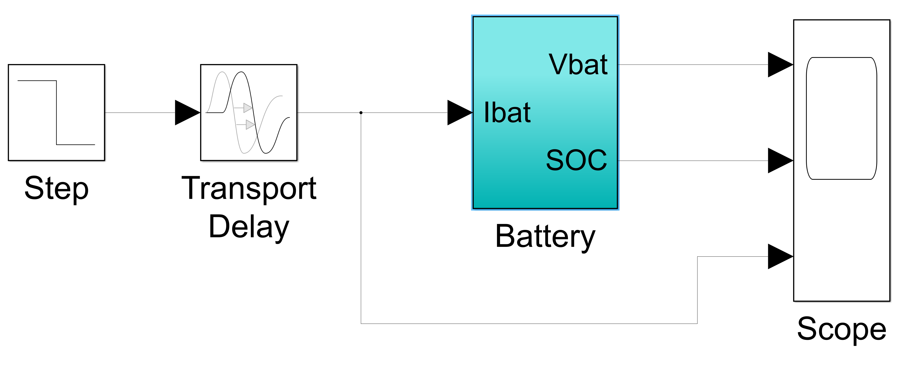
Fig. 8.1 Complete battery model with internal resistance.
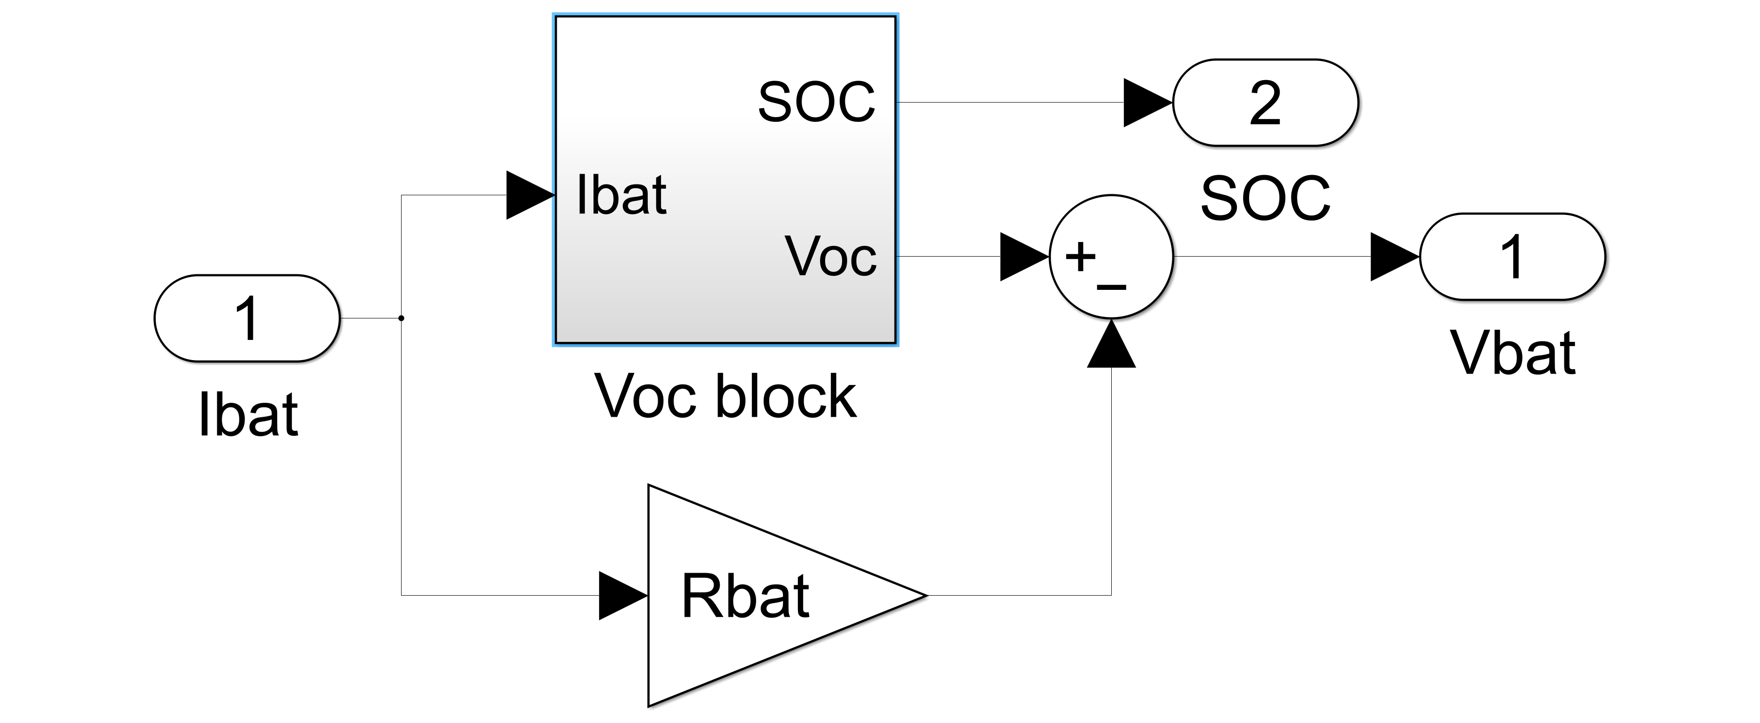
Fig. 8.2 Simulink model of battery subsystem.
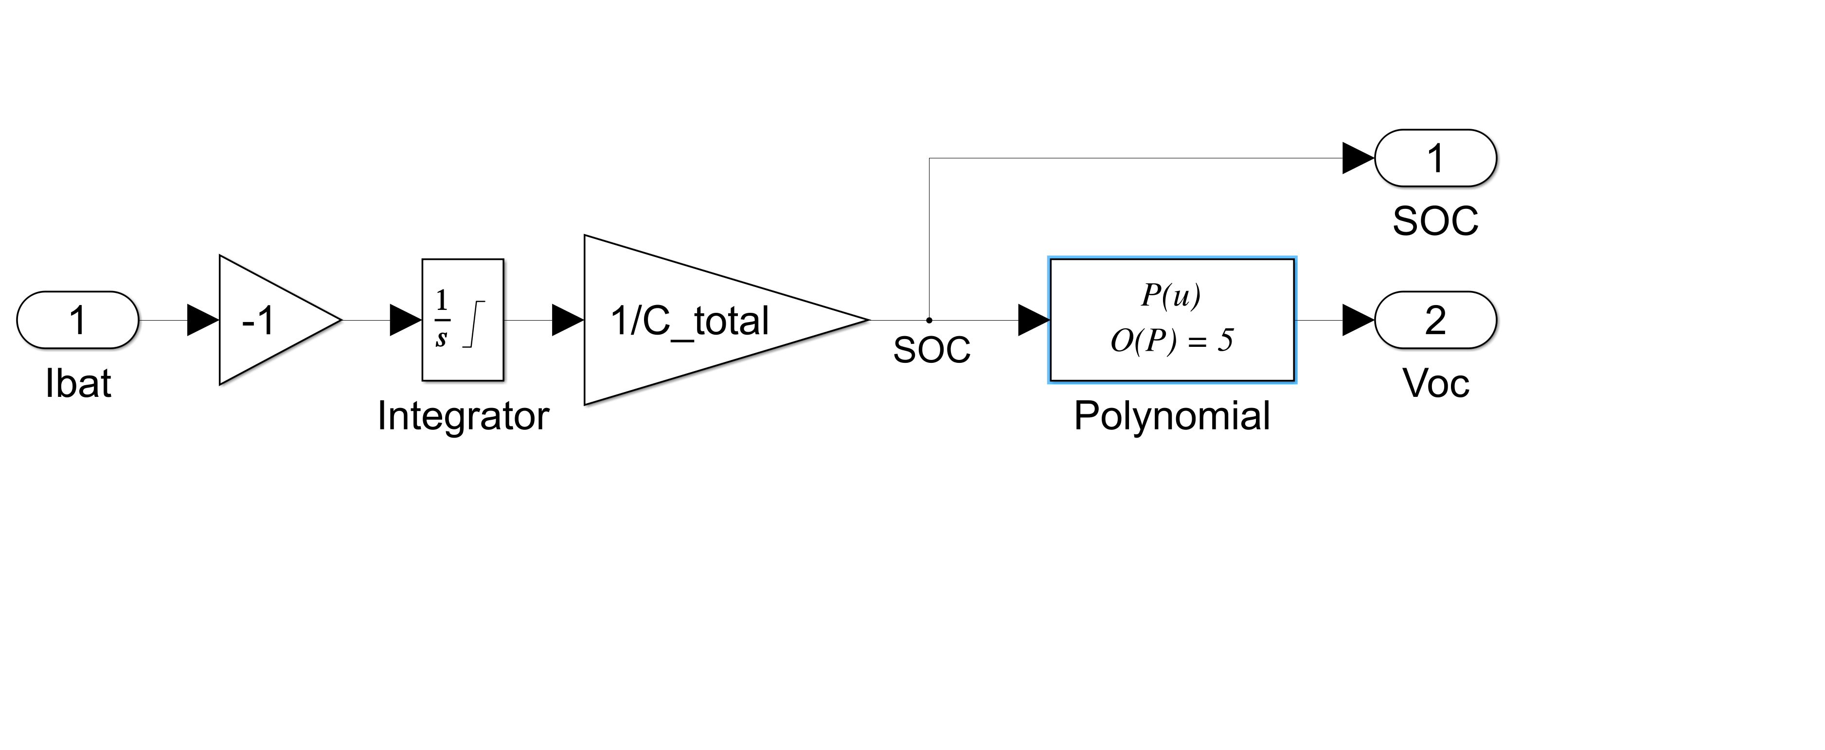
Fig. 8.3 Simulink model of Voc subsystem.

Apply following parameters for the blocks in the Simulink, keeping other parameters to their default values:
- Step block. Step time: Ttotal/2-900, Initial value: C_nom/3, Final value: -C_nom/3, Step time: 0
- Transport Delay. Time delay: 1200, Initial output: 0, Initial buffer size: 1024, Pade order: 0
- Integrator block. Initial condition: C_init, Upper saturation limit: C_total, Lower saturation limit: 0
- Polynomial block. Polynomial coefficients: P01A
- Scope block. General Number of input ports: 3; display grid: [3 1]. Logging Tick log data to workspace; variable name: ScopeData; save format: Structure With Time.

Once all the subsystems are developed, open the Battery_Parameters_R.m file and run the program to produce two figures. Next run the Battery_Thevenin_Model_R.slx file, wait for simulation to complete, and then run Battery_Plot_R.m file to produce one figure. Maximize all the figures. In the figure, go to Edit tab and press Copy Figure and paste in your lab report. Explain each plot thoroughly. Results without explanation will receive half the points only. Keep all the models you have developed in your report.

8.5 Designing Battery Model with Internal Resistance and Capacitance
Read Sections 9.5 in textbook to understand the battery models.

Set the current directory of MATLAB to the Lab8_Part2 folder. Otherwise, you will get errors in running the simulations.

Open the Battery_Thevenin_Model_RC.slx file. Do not run the simulation yet. The simulation file is empty, and it should be developed similarly to Figs. 8.4 to 8.5. Please note that the parameters in Simulink blocks are case sensitive. Change the Goto Tag visibility to “global”.
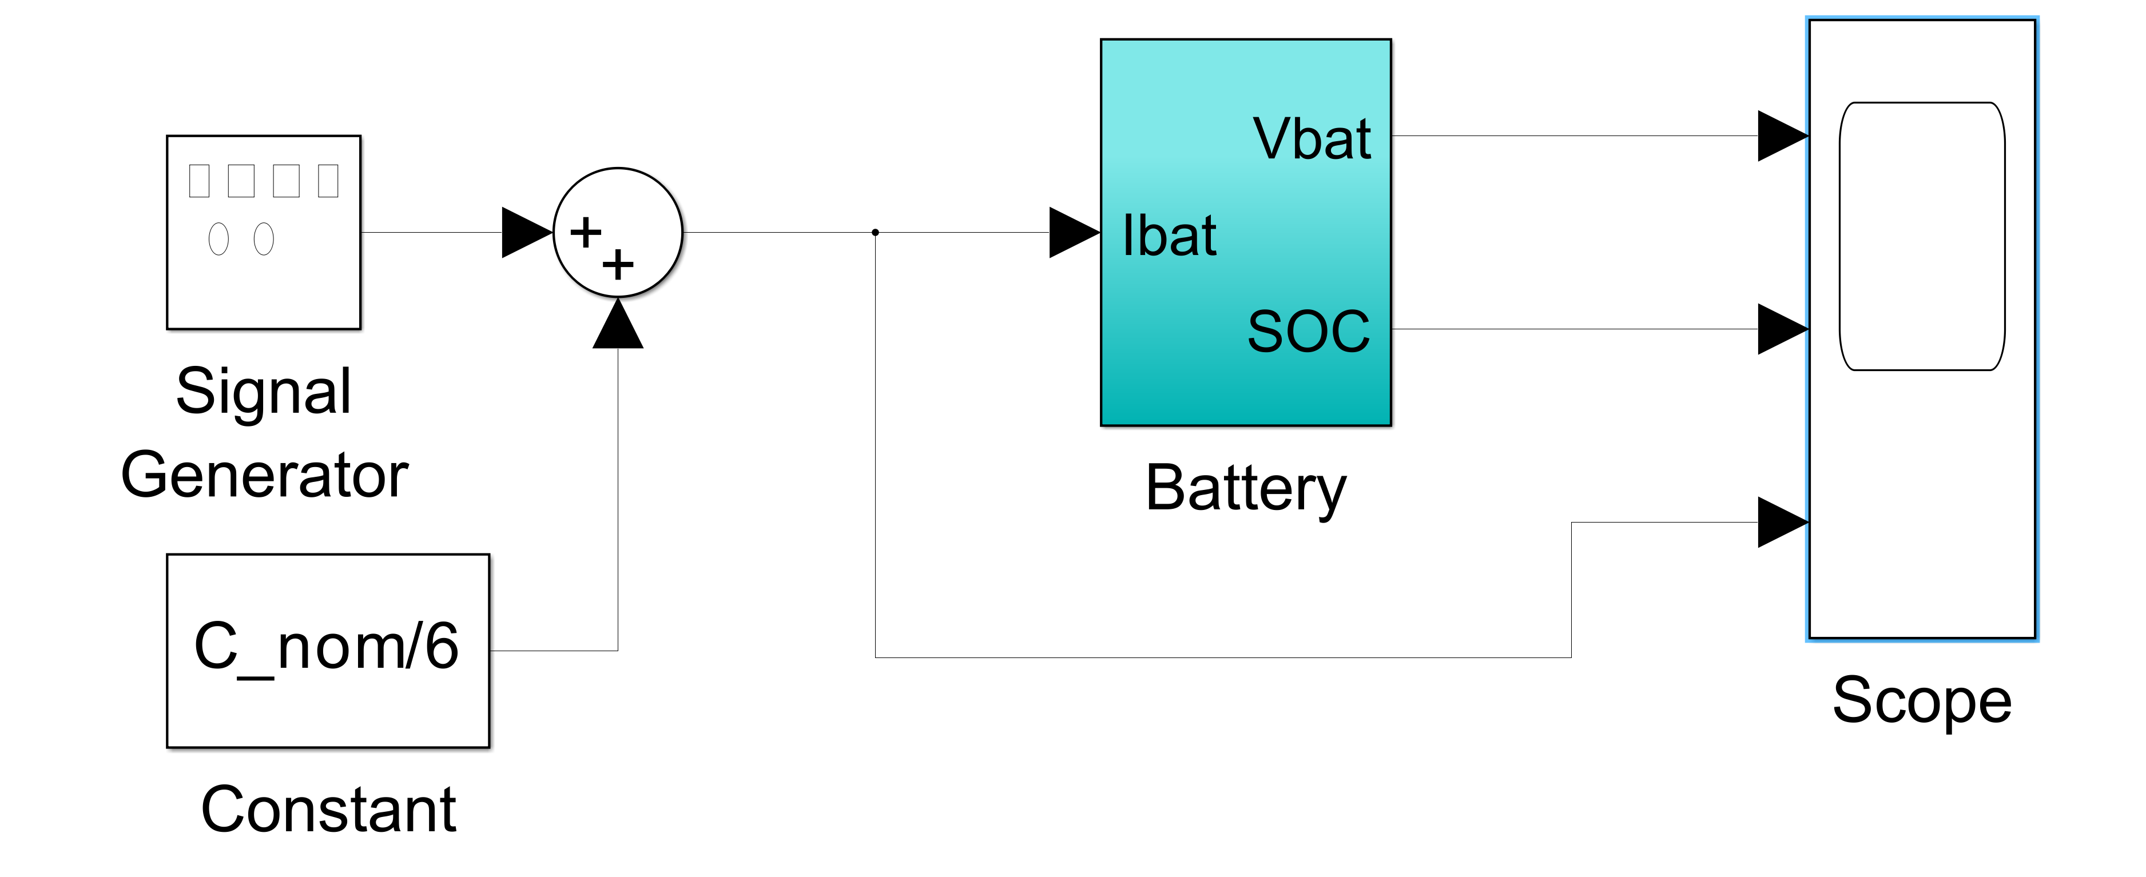
Fig. 8.4 Complete battery model with internal resistance and capacitance.

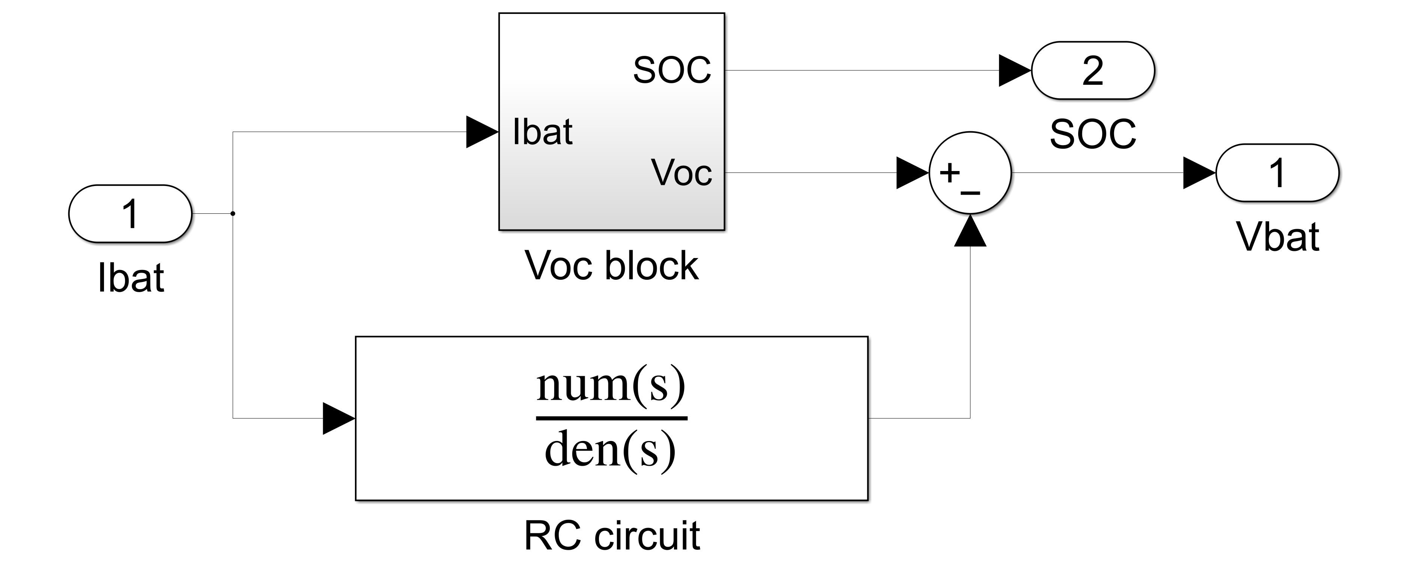
Fig. 8.5 Simulink model of battery subsystem.

Fig. 8.6 Simulink model of Voc subsystem (same as Fig. 8.3).

Voc subsystem and its parameters are same as in Part 1. Apply following parameters for the blocks in the Simulink, keeping other parameters to their default values:
- Signal Generator block. Amplitude: C_nom/6, Frequency: 0.1, Units: Hertz
- Transfer Function block (RC circuit). Numerator coefficients: [Rs*Rnl*Cd (Rs+Rnl)], Denominator coefficients: [Rnl*Cd 1]
- Scope block. General Number of input ports: 3; display grid: [3 1]. Logging Tick log data to workspace; variable name: ScopeData; save format: Structure With Time.

Once all the subsystems are developed, open the Battery_Parameters_RC.m file and run the program to produce two figures. Next run the Battery_Thevenin_Model_RC.slx file, wait for simulation to complete, and then run Battery_Plot_RC.m file to produce one figure. Maximize all the figures. In the figure, go to Edit tab and press Copy Figure and paste in your lab report. Explain each plot thoroughly. Results without explanation will receive half the points only. Keep all the models you have developed in your report.

8.6 Instructions for Lab Report
Detailed instructions for the lab report preparation are available on Canvas. Each team member should identify his/her portion of the writing in both the pre-lab (if exists) and post-lab reports.

The report should include the following results and analysis:
- 3 figures along with explanation for battery model with internal resistance
- 3 figures along with explanation for battery model with internal resistance and capacitance
- Screenshot of all simulation models you have developed

